Grammar Rules:
expression → term ((‘+’ | ‘-’) term)*
term → factor (‘*’ factor)*
factor → number | ‘(‘ expression ‘)’
number → digit digit*
digit → ‘0’ | ‘1’ | ‘2’ | ‘3’ | ‘4’ | ‘5’ | ‘6’ | ‘7’ | ‘8’ | ‘9’

These grammar rules follow consistently with the practical execution of expression evaluation in mathematics. These rules support the logical flow of PEMDAS for the applicable operations. The flow tracks the order of operations to the inner most section for initial execution before working its way out to the top layer and on to additional sections if needed. While these rules are somewhat more cumbersome by going token-by-token for deciding this overview, the order-of-operations is still maintained.
A point of divergence between the theoretical structure and real-world output of this program is that the granular identification of each individual token is not implemented in the real-world output like it is outlined in the theoretical structure. Each individual digit is not given significance and concatenated, but rather identified as an entire value for storage. Furthermore, the differentiation between all of the nonterminal values are not stored as individual variables, their significance is held in the operations themselves.

Parsing Diagram
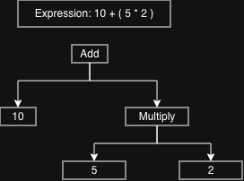
Program Output
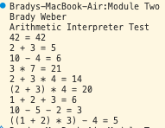

Python Parser program
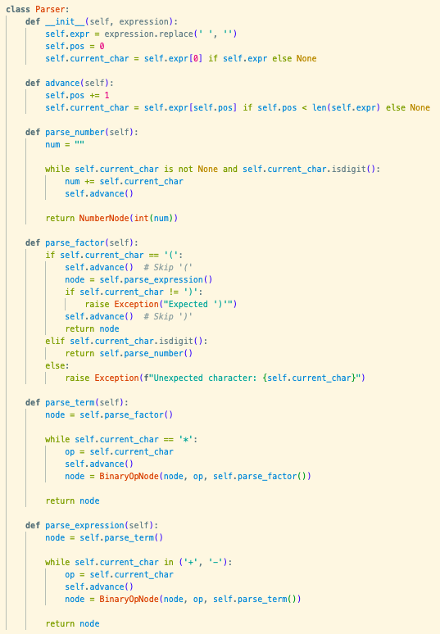

This python program corresponds to the original grammar rules by following the hierarchical parsing strategy displayed in the original rules: parse_expression is used to call the function for parsing a term, and then if there is an addition or subtraction operation, advance to the next term for parsing; parse_term is used to call the function for parsing the factor, and then if there is a multiplication operation, advance to the next factor for parsing; parse_factor is used to call the function to parse the number if applicable or identify a parentheses to make the recursive call back to the top to evaluate the new expression held between the opening and closing parenthesis; parse_number is used to identify the consecutive digits in order to concatenate them into a single larger number.
The grammar rules used for this program are designed around a depth-first tree which starts at the expression level and works its way down to the individual digits and operations within each sub-expression. The different levels of mathematical order-of-operations or PEMDAS are represented as specific levels in the grammar rules in which explicit checks need to be made to identify which operation should be performed when and where on which numbers and sub-expressions.
The diagram displays an example expression in which the operations are the main points of division. When an operation is identified, it is separated much like the BinaryOpNode class within the Python function. This object contains the left value, right value, and the operation. The surface level operations are executed first with each sub-expression underneath it. In this diagram the addition operation is the first expression to be evaluated with a number and a sub-expression. Within that sub-expression, the multiplication operation is identified with its children nodes both containing numbers.

